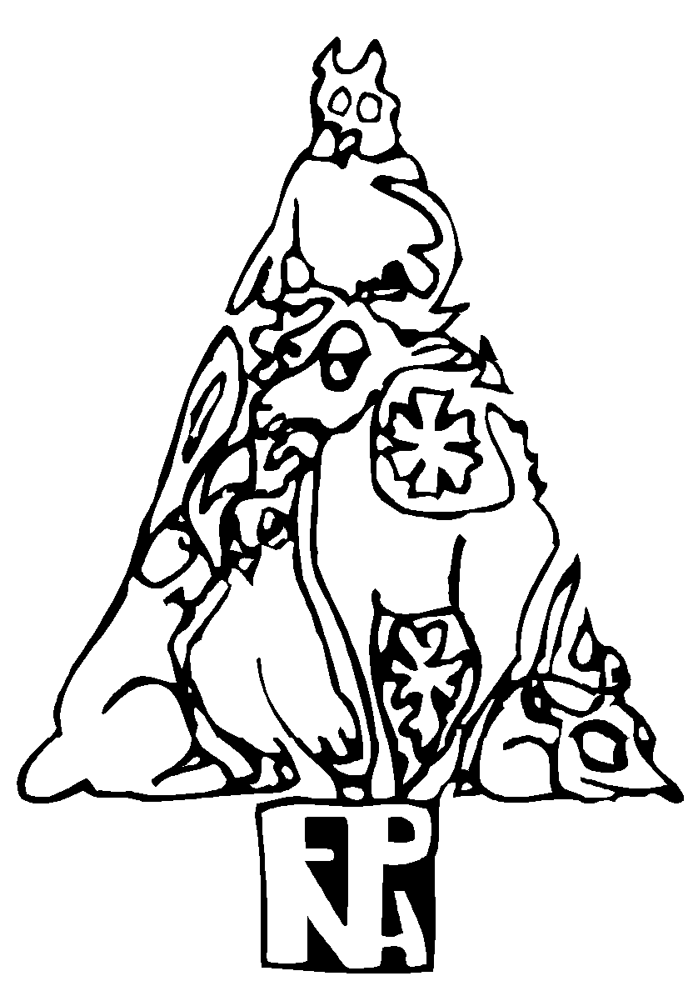 | Forest Park Neighborhood Association  C/O Neighbors West Northwest  434 NW 6th Ave. Suite 202  Portland, Oregon 97209  December 22, 2024

Morgan Steele | Land Use Services | Environmental Review & Greenway Review
503.865.6437 | Morgan.Steele@portlandoregon.gov
Christine Caruso | Land Use Services | Conditional Use Review
503.865.6420 | Christine.Caruso@portlandoregon.gov

REQUEST FOR RESPONSE
Case File: LU 24-041109 CU EN GW
Pre App: PC # 22-142445

Dear Morgan Steele and Christine Caruso,

Forest Park Neighborhood wants to add some supporting material to the Response we submitted December 4, 2024 in response to your November 4, 2024 Request For Response regarding PGE’s proposed transmission corridor project in Forest Park.

These files are attached:

- PGE Transmission Plans - Harborton Project Excerpts 2015-2024 122224
- PGE Tonquin Project pole height and width diagrams 112424
- NorthernGrid Regional Transmission Plan for the 2022-2023 Northern Grid Planning Cycle

A few notes related to these items.

The PGE Transmission Plans are referenced in our December 4, 2024 letter. This attachment includes excerpts for all Harborton related projects from the 2015-2024 transmission plans for easy reference.

Our December 4, 2024 letter referred to PGE’s Tonquin project power poles. We are now sending PGE’s graphics from their Tonquin project that show those poles.

PGE participates in NorthernGrid’s regional transmission planning. According to the NorthernGrid 2022-2023 Regional Transmission Plan (attached, see page 4):

The NorthernGrid is an unincorporated association of entities that either own or operate, or that propose to own or operate, electric transmission facilities in the Western Interconnection. The NorthernGrid promotes coordinated, open, and transparent transmission planning and facilitates compliance with Federal Energy Regulatory Commission (“FERC”) Orders No. 890 and 1000.

The purpose of this regional transmission plan is (page 18):

The objective of the regional transmission analysis is to identify a set of transmission projects that cost effectively or efficiently meet the transmission service and reliability needs of the NorthernGrid region 11 ten years in the future.

The final cost-effective NorthernGrid regional transmission plan, shown on page 20, doesn’t include any projects in western Oregon or Washington. There are no north/south projects to resolve problems with the South of Alston (SOA) path that PGE says in their Revised Narrative urgently needs to be fixed. This leaves us skeptical that this PGE project is as urgent as PGE says it is.

Oregon White Oak Mitigation – Allowed tree height?

PGE’s Mitigation Plan proposes planting Oregon White Oak alongside (but not directly below) their powerlines.

PGE proposes to expand the existing woodland in specific areas in the existing and proposed transmission corridors while still maintaining a vertical clear zone between the wires and the top of mature oak tree heights to remain consistent with PGE’s vegetation management protocols (see Figure 10). While oaks would not be planted directly beneath the wires, the edges of the cleared corridors would be amenable to the establishment of oaks. In total, the revegetation plan calls for the planting of 386 Oregon white oak trees in the Park.
Figure 10 in PGE’s Mitigation Plan shows oaks with only a 65’ mature height, but according to the Marion Soil and Water Conservation District, Oregon white oak (Quercus garryana) trees grow up to 100’ in height. The 65’ tall “mature oak” is also shown near a power pole, where the power lines are highest off the ground. Further from the pole, the lines will sag lower, further limiting oak tree height.

We also note that PGE’s easement allows powerlines to come within 32’ of the ground at their lowest point. We are concerned that many of the oaks that PGE proposes to plan alongside (but not directly under) their powerlines will be stunted by pruning, unable to reach their mature height and spread. Under Title 11, topped trees are considered removed. This would be a warped form of mitigation.

PGE’s Mitigation Plan is intended to satisfy the requirements in the Forest Park Natural Resources Management Plan, Chapter 8. Implementation Procedures, Section B: Exceptions to the Plan Approval Criteria for Exceptions to the Plan: The exception will be approved if:

(D). Any long-term adverse impacts of the proposed action on resource values are fully mitigated
within the Management Unit.

Based on the information presented in the Mitigation Plan, we aren’t confident that PGE’s plan to mitigate resource damage by planting oaks near the transmission lines is viable.

Forest Park Neighborhood respectfully requests city staff to recommend against approving this application.

We appreciate city staff’s hard work to evaluate and respond to this complex and technical application.

Thank you for your consideration. Sincerely,

Carol Chesarek
Co-Chair, Forest Park Neighborhood Association Land Use Committee

Forest Park Neighborhood welcomes everyone: all races, religions, countries of origin, sexual orientations, genders and abilities. Our neighborhood is enriched by the diversity of our residents and community members. Each individual has dignity and the potential to contribute to our community as a whole. We embrace and respect one another first as neighbors, and we strive to look out for each other. We encourage everyone to engage with our neighborhood to create a welcoming and safe place to live, work and recreate. Hate has no home here.

https://www.northerngrid.net/private-media/documents/2022-23_Regional_Transmission_Plan.pdf retrieved 122324
LU 24-041109 Revised Application for: Portland General Electric Company (PGE) Harborton Reliability Project, October 28, 2024. Narrative, Applicant’s Written Statement, page 9.
LU 24-041109 Harborton Reliability Project Habitat Mitigation Plan City of Portland Land Use Application Appendix D, page 49
Mitigation Plan, Appendix D, page 51
https://www.marionswcd.net/plants/oregon-white-oak/ retrieved 122224
LU 24-041109 Appendix_F_Existing_PGE_Utility_Easement_in_Forest_Park, page 14

