# [PGE Transmission Plans 2015 – 2024](http://www.oasis.oati.com/pge/) | Harborton Related Project Excerpts

## 2015 Plan: Portland General Electric Company’s Longer Term Local Transmission Plan for the 2014-2015 Planning Cycle, Appendix A, Page 17 [www.oasis.oati.com/woa/docs/PGE/PGEdocs/PGE_Long_Term_LTP_2015_FINAL.pdf](http://www.oasis.oati.com/woa/docs/PGE/PGEdocs/PGE_Long_Term_LTP_2015_FINAL.pdf) Harborton Reliability Project

* **Project Purpose**
  + Address transmission operations flexibility for the loss of the Rivergate bulk power transformer.
  + Reconfigure the system to reduce exposure and provide a stronger source to the Northwest Portland 115kV system.
* **Project Scope**
  + Rebuild the Harborton 115kV yard to a breaker and one half configuration.
  + Build a new 230kV breaker and one half yard at Harborton substation.
  + Route five 230kV lines to Harborton.
  + Install a new bulk power transformer at Harborton.
  + Reconductor the 115kV lines from Harborton to Canyon.
  + Reconfigure the 115kV system to provide a source to Northwest Portland from Harborton substation.
* **Project Status**
  + Project planning is complete; this project was submitted for inclusion in the 2016 capital budget and was recommended for approval.
* **Project Requirement Date**
  + The project is currently projected for completion in 2021.

## 2016 Plan: Portland General Electric’s Near Term Local Transmission Plan for the 2016-2017 Planning Cycle, Appendix A, Page 16 [www.oasis.oati.com/woa/docs/PGE/PGEdocs/PGE_Near_Term_LTP_2016_FINAL.pdf](http://www.oasis.oati.com/woa/docs/PGE/PGEdocs/PGE_Near_Term_LTP_2016_FINAL.pdf)

## Harborton Reliability Project

* **Project Purpose**
  + Address transmission operations flexibility for the loss of the Rivergate bulk power transformer.
  + PGE plans to reconstruct the Harborton substation with a new 115kV yard and add a new 230kV yard. The 230kV sources will be provided by looping in the existing Trojan-Rivergate 230kV line, and the Horizon-Trojan-St Marys 230kV line (see the Horizon Phase II project). The new Harborton bulk power transformer will provide a strong source to improve voltage and power flow performance of the Northwest Portland 115kV system.
* **Project Scope**
  + Rebuild the Harborton 115kV yard to a breaker and one half configuration.
  + Build a new 230kV breaker and one half yard at Harborton substation.
  + Route five 230kV lines to Harborton.
  + Install a new bulk power transformer at Harborton.
  + Reconductor the 115kV lines from Harborton substation to Canyon substation.
  + Reconfigure the 115kV system to provide a source to Northwest Portland from Harborton substation.
* **Project Status**
  + Under Construction
* **Project Requirement Date**
  + The project is currently projected for completion in 2020.

## 2017 Plan: Portland General Electric Company’s Longer Term Local Transmission Plan for the 2016-2017 Planning Cycle, Appendix A, Page 14.

## [www.oasis.oati.com/woa/docs/PGE/PGEdocs/PGE_Long_Term_LTP_2017_FINAL.pdf](http://www.oasis.oati.com/woa/docs/PGE/PGEdocs/PGE_Long_Term_LTP_2017_FINAL.pdf)

## Lower Columbia Resiliency Project

* **Project Purpose**:   
  + Increase transfer capacity into the Portland area via the South of Allston transfer path
* **Project Scope**:   
  + Construct a new 230kV transmission line from Trojan Substation to Harborton Substation
* **Project Status**:   
  + Preliminary planning
* **Project Requirement Date**:   
  + No date established; TBD

## 2018 Plan: Portland General Electric Company’s Near Term Local Transmission Plan for the 2018-2019 Planning Cycle, Appendix A, Page 16.

[www.oasis.oati.com/woa/docs/PGE/PGEdocs/PGE_DRAFT_Near_Term_LTP_2018.pdf](http://www.oasis.oati.com/woa/docs/PGE/PGEdocs/PGE_DRAFT_Near_Term_LTP_2018.pdf)

## Harborton Reliability Project

* **Project Purpose**
  + Address transmission operations flexibility for the loss of the Rivergate bulk power transformer.
  + Reconfigure the system to reduce exposure and provide a stronger source to the Northwest Portland 115kV system.
* **Project Scope**
  + Rebuild the Harborton 115kV yard to a breaker and one half configuration.
  + Build a new 230kV breaker and one half yard at Harborton substation.
  + Route five 230kV lines to Harborton.
  + Install a new bulk power transformer at Harborton.
  + Reconductor the 115kV lines from Harborton to Canyon.
  + Reconfigure the 115kV system to provide a source to Northwest Portland from Harborton substation.
* **Project Status**
  + Under Construction
* **Project Requirement Date**
  + The project is currently projected for completion in 2020.

## 2019 Plan: Portland General Electric Company’s Longer Term Local Transmission Plan for the 2018-2019 Planning Cycle, Appendix A, Page 16.

[www.oasis.oati.com/woa/docs/PGE/PGEdocs/PGE_Longer_Term_LTP_2019_FINAL.pdf](http://www.oasis.oati.com/woa/docs/PGE/PGEdocs/PGE_Longer_Term_LTP_2019_FINAL.pdf)

## Lower Columbia Resiliency Project

* **Project Purpose**:   
  + Increase transfer capacity into the Portland area via the South of Allston transfer path.
* **Project Scope**:   
  + Construct a new 230kV transmission line from Trojan Substation to Harborton Substation.
  + Reconductor the existing Harborton-Rivergate 230kV line river crossing.
* **Project Status**:   
  + PGE is exploring implementing this project in the Longer Term Planning Horizon. This project will be submitted for a regional coordination study in accordance with FERC Order 1000.
* **Project Requirement Date**:   
  + No date established; TBD.

## 2020 Plan: Portland General Electric Company’s Near Term Local Transmission Plan for the 2020-2021 Planning Cycle, Appendix A, Page 14.

[www.oasis.oati.com/woa/docs/PGE/PGEdocs/PGE_Near_Term_LTP_2020_Final.pdf](http://www.oasis.oati.com/woa/docs/PGE/PGEdocs/PGE_Near_Term_LTP_2020_Final.pdf)

## Harborton Reliability Project

* **Project Purpose**
  + Address transmission operations flexibility for the loss of the Rivergate bulk power transformer.
  + Reconfigure the system to reduce exposure and provide a stronger source to the Northwest Portland 115 kV system.
* **Project Scope**
  + Rebuild the Harborton 115 kV yard to a breaker and one half configuration.
  + Build a new 230 kV breaker and one half yard at Harborton substation.
  + Route five 230 kV lines to Harborton.
  + Install a new bulk power transformer at Harborton.
  + Reconductor the 115 kV lines from Harborton to Canyon.
  + Reconfigure the 115 kV system to provide a source to Northwest Portland from Harborton substation.
* **Project Status**
  + Under Construction.
* **Project Requirement Date**
  + The initial Phase 1 of this project includes the 115 kV yard rebuild, the Harborton-Rivergate 115 kV circuit and Harborton-St Helens 115 kV circuit. This phase was completed in April 2020.
  + The remaining Phase 1 of this project includes the 230 kV yard, the Harborton-Rivergate 230 kV circuit, the Harborton-Trojan #1 230 kV circuit and the new bulk power transformer. This phase is scheduled for completion by Q2 2021.
  + Phase 2 of this project first reconductors the E-Wacker 115 kV line to 1272 ACSS. Next, the 115 kV system is reconfigured to create a Harborton-Wacker 115 kV circuit, which will also be reconductored to 1272 ACSS. The 115 kV line idled for this reconfiguration will be utilized for the fifth 230 kV source into Harborton. The Horizon-St Marys-Trojan 230 kV circuit will be looped into Harborton, creating the Harborton-Horizon 230 kV, Harborton-St Marys 230 kV, and Harborton-Trojan #2 230 kV circuits. This phase is scheduled to begin after the Canyon-Urban 115 kV Reconductor and is scheduled for completion by 2025.

## 2021 Plan: Portland General Electric Company’s Longer Term Local Transmission Plan for the 2020-2021 Planning Cycle, Appendix A, Page 26.

[www.oasis.oati.com/woa/docs/PGE/PGEdocs/PGE_Longer_Term_LTP_2021_FINAL.pdf](http://www.oasis.oati.com/woa/docs/PGE/PGEdocs/PGE_Longer_Term_LTP_2021_FINAL.pdf)

## Evergreen-Harborton 230kV Reconductor Project

* **Project Purpose**:   
  + Increase the capacity of the Evergreen-Harborton 230kV line to eliminate thermal overload concerns.
* **Project Scope**:   
  + Reconductor the Evergreen-Harborton 230kV circuit (approximately 10.01 miles) to 1272 ACSS.
* **Project Status**:   
  + Preliminary planning.
* **Project Requirement Date**:   
  + Estimated 6/2029

***>> NOTE: This is the only Harborton related project in the 2021 Plan <<***

## 2022 Plan: Portland General Electric Company’s Near Term Local Transmission Plan for the 2022-2023 Planning Cycle, Appendix A, Page 16.

[www.oasis.oati.com/woa/docs/PGE/PGEdocs/Final_Near_Term_LTP_2022_12-28-22.pdf](http://www.oasis.oati.com/woa/docs/PGE/PGEdocs/Final_Near_Term_LTP_2022_12-28-22.pdf)

## Harborton Reliability Project

* **Project Purpose**
  + Address transmission operations flexibility for the loss of the Rivergate bulk power transformer.
  + Reconfigure the system to reduce exposure and provide a stronger source to the Northwest Portland 115 kV system.
* **Project Scope**
  + Rebuild the Harborton 115 kV yard to a breaker and one half configuration.
  + Build a new 230 kV breaker and one half yard at Harborton substation.
  + Route five 230 kV lines to Harborton.
  + Install a new bulk power transformer at Harborton.
  + Reconductor the 115 kV lines from Harborton to Canyon.
  + Reconfigure the 115 kV system to provide a source to Northwest Portland from Harborton substation.
* **Project Status**
  + Under Construction.
* **Project Requirement Date**
  + The initial Phase 1 of this project includes the 115 kV yard rebuild, the Harborton-Rivergate 115 kV circuit and Harborton-St Helens 115 kV circuit. This phase was completed in April 2020.
  + The remaining Phase 1 of this project includes the 230 kV yard, the Harborton-Rivergate 230 kV circuit, the Harborton-Trojan #1 230 kV circuit and the new bulk power transformer. This phase is scheduled for completion by Q2 2021.
  + Phase 2 of this project first reconductors the E-Wacker 115 kV line to 1272 ACSS. Next, the 115 kV system is reconfigured to create a Harborton-Wacker 115 kV circuit, which will also be reconductored to 1272 ACSS. The 115 kV line idled for this reconfiguration will be utilized for the fifth 230 kV source into Harborton. The Horizon-St Marys-Trojan 230 kV circuit will be looped into Harborton, creating the Harborton-Horizon 230 kV, Harborton-St Marys 230 kV, and Harborton-Trojan #2 230 kV circuits. This phase is scheduled to begin after the Canyon-Urban 115 kV Reconductor and is scheduled for completion by Q3 2026.

## 2023 Plan: PGE Long Term Local Transmission Plan for the 2023-2024 Planning Cycle, Corrective Action Plans (Planned Projects), Page 24 and Interconnection and Renewables Access Projects, Page 44.

## [www.oasis.oati.com/woa/docs/PGE/PGEdocs/2023_Local_Transmission_Plan.pdf](http://www.oasis.oati.com/woa/docs/PGE/PGEdocs/2023_Local_Transmission_Plan.pdf)

## Page 19 shows a Project Completion Date of November 2026 for Harborton Reliability Project. Page 43 shows a Project Completion Date of April 2030 for Harborton-Trojan #3 and #4 230kV.

## Harborton Reliability Project (page 24)

**Justification**: The Harborton reliability project reconfigures the system to increase 230kV transmission capacity into the Portland area and provide a stronger source to the Northwest Portland 115kV system. One key purpose of this project is that it addresses transmission operations flexibility for the loss of the Rivergate bulk power transformer. The Harborton 115kV and 230kV yards will be constructed in a breaker and a half configuration with five 230kV lines into Harborton and three 115kV lines. One bulk 230/115kV transformer at Harborton is also installed. The Canyon-E 115kV line will be reconductored during the project.

**Scope**: Currently underway for this project is a reconductor to the E-Wacker 115 kV line to 1272 ACSS. Next, the 115 kV system will be reconfigured to create a Harborton-Wacker 115 kV circuit, which will also be reconductored to 1272 ACSS. The 115 kV line idled for this reconfiguration will be utilized for the fifth 230 kV source into Harborton. The Horizon-St Marys-Trojan 230 kV circuit will be looped into Harborton, creating the Harborton-Horizon 230 kV, Harborton-St Marys 230 kV, and Harborton-Trojan #2 230 kV circuits.

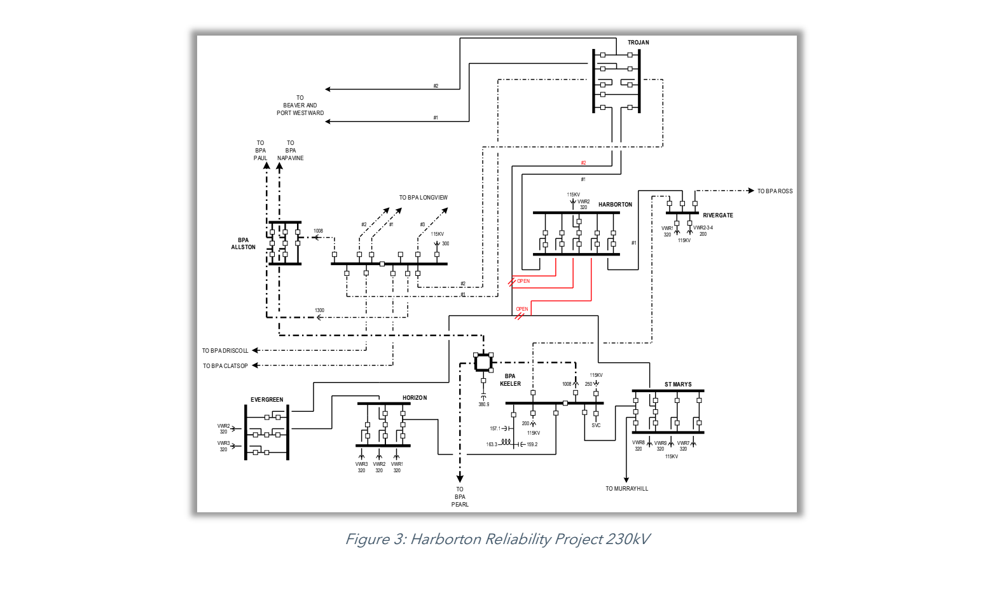

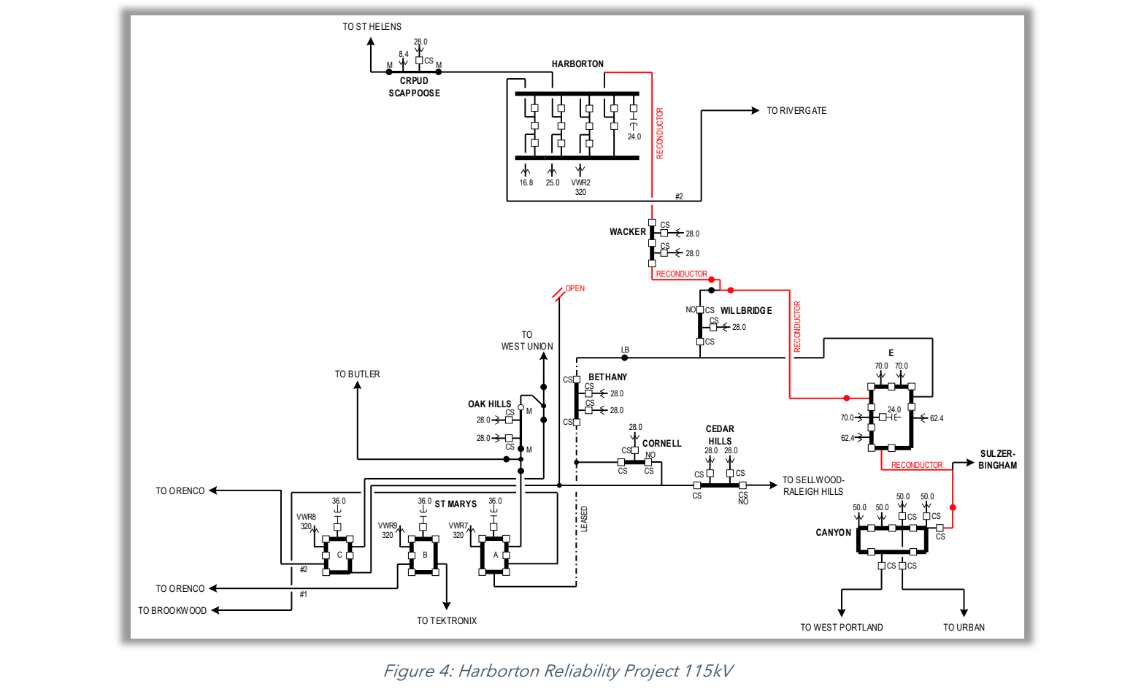

## Harborton-Trojan #3 and #4 230kV (page 44)

**Justification**: This project was identified in order to access new, decarbonized resources in order for PGE to meet obligations under Oregon’s HB 2021 law. The lines will be part of the SOA path, which is fully subscribed. Because of power transfer distribution factor (PTDF), nearly all transfers of power from any part of the WECC footprint have at least some impact on SOA. Given that SOA is fully subscribed, no new transmission service is available to PGE’s service territory without adding new incremental capacity to the SOA path. It will construct two additional lines from Trojan to Harborton, utilizing existing right-of-way. This project will alleviate market congestion constraints on the SOA path for PGE and increase the total transfer capability between BPA and PGE.

**Scope**: PGE to construct two 230kV lines from Harborton to Trojan using existing right-of-way. The Harborton-Rivergate #1 230kV line will also be reconductored as part of this project.

**Project Status**: PGE is exploring implementing this project in the Longer Term Planning Horizon. This project will be submitted for a regional coordination study.

## 2024 Draft Plan: PGE Near Term Local Transmission Plan *Draft* for the 2024-2025 Planning Cycle, Corrective Action Plans, Pages 20, 21 and Interconnection and Renewables Access Projects, Page 30.

## [www.oasis.oati.com/woa/docs/PGE/PGEdocs/2024_Local_Transmission_Plan-Draft.pdf](http://www.oasis.oati.com/woa/docs/PGE/PGEdocs/2024_Local_Transmission_Plan-Draft.pdf)

## Page 19 shows a Project Completion Date of April 2029 for Evergreen-Harborton and Harborton/St Marys 230kF Reconductor. Page 20 shows a Project Completion Date of November 2026 for Harborton Reliability Project. Page 43 shows a Project Completion Date of April 2030 for Harborton-Trojan #3 and #4 230kV.

## Evergreen-Harborton and Harborton-St Marys 230kV Reconductor (page 20)

**Justification:** 5-year planning models indicate significant N-1-1 overloading on Evergreen Harborton. 10-year planning models indicate significant N-1-1 overloading on Harborton-St Marys as well. Given that both circuit run on common towers, it is recommended to reconductor both simultaneously to reduce cost and environmental impact in sensitive areas**.**

**Scope:** Reconductor both Evergreen -Harborton 230kV and Harborton-St Marys 230kV lines for all sections that are not currently 2156 ACSS.

## Harborton Reliability Project (page 21)

**Justification**: The Harborton reliability project reconfigures the system to increase 230kV transmission capacity into the Portland area and provide a stronger source to the Northwest Portland 115kV system. One key purpose of this project is that it addresses transmission operations flexibility for the loss of the Rivergate bulk power transformer. The Harborton 115kV and 230kV yards will be constructed in a breaker and a half configuration with five 230kV lines into Harborton and three 115kV lines. One bulk 230/115kV transformer at Harborton is also installed. The Canyon-E 115kV line will be reconductored during the project.

**Scope**: Currently underway for this project is a reconductor to the E-Wacker 115 kV line to 1272 ACSS. Next, the 115 kV system will be reconfigured to create a Harborton-Wacker 115 kV circuit, which will also be reconductored to 1272 ACSS. The 115 kV line idled for this reconfiguration will be utilized for the fifth 230 kV source into Harborton. The Horizon-St Marys-Trojan 230 kV circuit will be looped into Harborton, creating the Harborton-Horizon 230 kV, Harborton-St Marys 230 kV, and Harborton-Trojan #2 230 kV circuits.

## Harborton-Trojan #3 and #4 230kV (page 30)

**Justification**: This project was identified in order to access new, decarbonized resources in order for PGE to meet obligations under Oregon’s HB 2021 law. The lines will be part of the SOA path, which is fully subscribed. Because of power transfer distribution factor (PTDF), nearly all transfers of power from any part of the WECC footprint have at least some impact on SOA. Given that SOA is fully subscribed, no new transmission service is available to PGE’s service territory without adding new incremental capacity to the SOA path. It will construct two additional lines from Trojan to Harborton, utilizing existing right-of-way. This project will alleviate market congestion constraints on the SOA path for PGE and increase the total transfer capability between BPA and PGE.

**Scope**: PGE to construct two 230kV lines from Harborton to Trojan using existing right-of-way. The Harborton-Rivergate #1 230kV line will also be reconductored as part of this project.