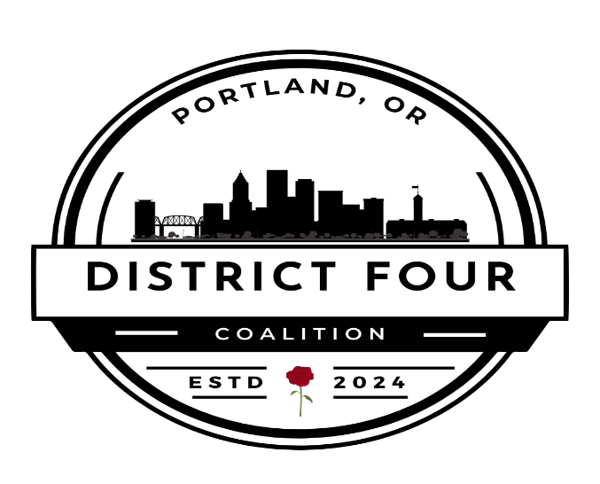
District 4 Coalition
Board of Directors
Agenda
April 7, 2025, 6:00 PM to 8:00 PM

6:00 pm to 6:10 pm Call to order Jessie Burke, Welcome and Introductions
6:10 pm to 6:15pm Announcements
- Conversation with a Cop (Sally Kneuven)

6:15 pm to 6:20 pm Approve Agenda Review and Changes

6:20 to 6:25 pm Approve Consent Agenda

6:25pm to 6:30pm Report from the Executive Director

6:30pm to 6:50pm Informative

Committees and Reports:
- Executive Committee (Kent Snyder/Jessie Burke)
- Finance (Gary Berger)
  - Report on Financial Education session
- Communications (Leslie Hammond)
- Land Use & Transportation (Mary Jaron Kelly)
- Housing Solutions (Ken Thrasher)

6:50pm to 7:20pm Vote Required:
- Governance Committee
  - Vote to authorize President to appoint members & chair
- Finance Committee
  - Vote on approve “District 4 Coalition Financial Policies and Procedures dated 1.22.2025”
- Executive Session re: Code of Conduct and Ethics – complaint.
7:20 pm to 7:30 pm Generative:

Adjourn

ATTACHMENT (STILL PUTTING THIS TOGETHER)

City Council Committees DATES AND TIMES:
- Transportation and Infrastructure:
- Olivia Clark, chair (District 4)
- Angelita Morillo, vice Chair (District 3)
- Loretta Smith (District 1)
- Mitch Green (District 4)
- Tiffany Koyama Lane (District 3)
- Homelessness and Housing:
- Candace Avalos, chair (District 1)
- Jamie Dunphy, vice chair (District 1)
- Angelita Morillo (District 3)
- Dan Ryan (District 2)
- Eric Zimmerman (District 4)
- Climate, Resilience, and Land Use:
- Steve Novick, co-chair (District 3)
- Angelita Morillo, co-chair (District 3)
- Candace Avalos (District 1)
- Dan Ryan (District 2)
- Sameer Kanal (District 2)
- Community and Public Safety:
- Steve Novick, co-chair (District 3)
- Sameer Kanal, co-chair (District 2)
- Angelita Morillo (District 3)
- Eric Zimmerman (District 4)
- Loretta Smith (District 1)
- Arts and Economy:
- Mitch Green, co-chair (District 4)
- Dan Ryan, co-chair (District 2)
- Jamie Dunphy (District 1)
- Loretta Smith (District 1)
- Olivia Clark (District 4)
- Labor and Workforce Development:
- Loretta Smith, chair (District 1)
- Mitch Green, vice chair (District 4)
- Jamie Dunphy (District 1)
- Steve Novick (District 3)
- Sameer Kanal (District 2)
- Finance:
- Eric Zimmerman, chair (District 4)
- Elana Pirtle-Guiney, vice chair (District 2)
- Candace Avalos (District 1)
- Mitch Green (District 4)
- Steve Novick (District 3)
- Governance:
- Tiffany Koyama Lane, chair (District 3)
- Dan Ryan, vice chair (District 2)
- Elana Pirtle-Guiney (District 2)
- Jamie Dunphy (District 1)
- Olivia Clark (District 4)

- Motion to Change the September board meeting to Sept 8th Kent Snyder
- City Budget – discussion about Strategy, Tactics, and Timing
- Finance Committee – Approval of Financial Policies and Procedures
- Building relationships with City Councilors

