**NWNW Visioning 2020**

**April 30, 4 pm**

NWNW into the new decade!

It has become more and more clear, especially over this last year, that NWNW needs to evolve beyond the current model of providing support services almost exclusively to its member neighborhood associations. Not only has technology evolved but also access to systems, and general administrative solutions, so that neighborhood volunteers are able to be increasingly independent. In addition to this reduction in demand on services, the inequities of the past have taken center stage, and actively working to support previously under-served populations is no longer suggested but essential, even (and especially) if they don’t filter in through our established channels. Given these circumstances (and because its about time!) NWNW staff want to move this organization forward. The path is clearer than it has been in the past, but we need your support and guidance to make this change. Board support for this process will be essential, so any additional work you can do in the background to encourage others to look forward will be highly valuable. The agenda reflects the areas of focus that we find most prudent to get this process moving. If you have other ideas or strategies, please feel free to throw them into the mix as well. Thank you for participating in this process and being part of the change!

Agenda items for Discussion

* Mission Statement
* Values
* Board Structure
* Expanding Services and Programs

What tools/resources does NWNW need to develop to demonstrate the commitment to equity, inclusion, and diversity?

* Racial Equity Policy
* Equity & Diversity Best Practices
* List of meeting guidelines to be used at each meeting

Some background resources for consideration.

**How to write a mission statement:**

<https://www.thebalancesmb.com/how-to-write-the-ultimate-nonprofit-mission-statement-2502262>

<https://nonprofithub.org/starting-a-nonprofit/nonprofit-mission-statements-good-and-bad-examples/>

Great Values statement and ideas for services, especially under “Community capacity building” <https://www.seuplift.org/>

**Mission Statement**

*The Neighbors West-Northwest Coalition promotes direct participation in grassroots democracy by supporting community efforts at the neighborhood level. Our services advance the voices of our constituent Neighborhood Associations as they strive to create livable, sustainable and equitable communities.*

Current Tagline: *Westside neighborhoods working toward a livable and sustainable future*.

Some examples from other coalitions:

“The Mission of the East Portland Community Office is to **support** the community building and advocacy activities of the **diverse communities** that live, work, play and come together in East Portland.”

“Southwest Neighborhoods, Inc. **empowers** **citizen** action to improve and maintain the **livability** of Southwest neighborhoods.”

“To **collaborate** with the SE Portland **community** to build informed, inclusive, and participatory neighborhoods that **support our** social and ecological **well-being**.”

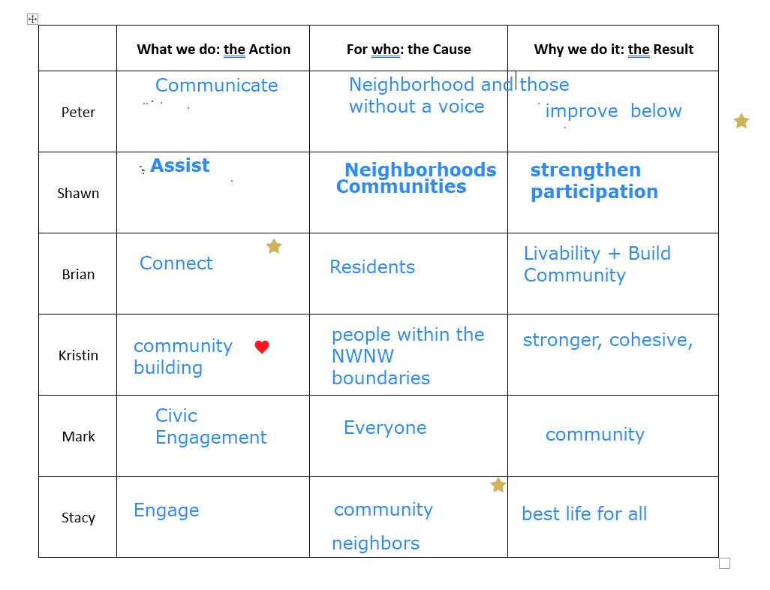

|  |  |  |  |
| --- | --- | --- | --- |
|  | **What we do: the Action** | **For who: the Cause** | **Why we do it: the Result** |

**Values: Not just what we do but how we go about it**

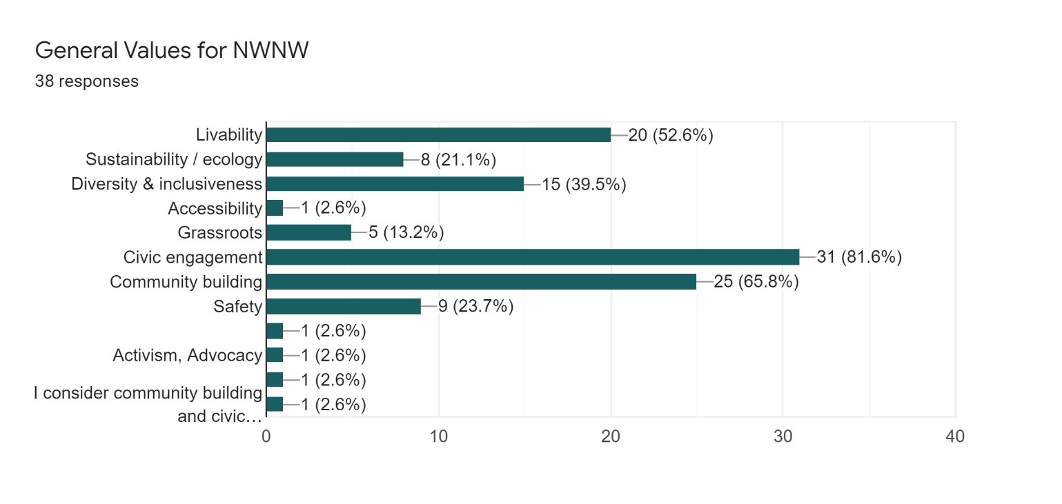

From online poll distributed to all past NWNW board members and current neighborhood board members. Looking back on this, we missed some key ideals, so if we adopt the top 3, there are some that could be added.

If we consider **Civic engagement and community building** as one category it drastically outweighs the others. **Livability and safety** easily fall into second place. And then **Diversity & Inclusiveness**.

Added comments:

|  |
| --- |
| Civic Engagement and diversity & inclusiveness should be leveraged to support the other topic (livability, safety, sustainability, so on...) |
| I consider community building and civic engagement as one value; I see livability including safety |
| Leadership development for neighborhood association boards |

Liaison between parties/sectors

Bringing together voices for some that don’t feel they have a voice

Help quiet voices rise up

Advocate for values,

Power of volunteer motives(?)

Legal requirements vs practical.

Connecting people to people, and the people to power

Equity

Reappropriate your privilege to benefit others

Working toward good of the whole. How can we support those within and also without our boundaries?

Examples:

**SE Uplift**

**We Believe:**

* **Relationship-Building:** Personal connections and networks strengthen our communities.
* **Community Involvement:**Organized neighbors can shape the future of our communities, including envisioning and enacting positive change. Through collaboration, we co-create the communities we want to inhabit.
* **Grassroots Democracy:**We all have a role in determining the character and future of our city through grassroots, bottom-to-top participation.
* **Sharing, Teaching and Learning:**With tools, support, and opportunities to connect, we can effect positive change.
* **Diversity and Inclusiveness:** In an inclusive, multicultural environment, through which we can explore our differences and come together around common interests and goals.
* **Building Capacity:** We strengthen our communities as we strengthen our neighborhood associations, community based organizations and business districts.

**East**

**Goals:** Increase the number of community partnerships to

(1) increase the number and diversity of people involved in their community

(2) strengthen community capacity to engage civically, and

(3) increase community impact on public decision-making.

**Board Structure – Bylaws Revisions**

This is obviously a much bigger conversation that will need to take place and require bylaws changes, but we want to start pulling ideas together on how it could look. Some thoughts to consider:

* What are eligibility requirements? Representatives from organizations or groups. Partners with common values
  + Advisory board
  + Committees for broad participation, short term projects
* How would a potential candidate demonstrate commitment to our values and goals? RFP from organizations
* How would they be appointed?
* Requirements on location?
* Unanimous consent for all advocacy/participatory actions? NO
* NWNW having more proactive role, independently from NAs.

What tools/resources does NWNW need to develop to demonstrate the commitment to equity, inclusion, and diversity?

* Racial Equity Policy
* Equity & Diversity Best Practices
* List of meeting guidelines to be used at each meeting

**Ideas for new or expanding services and programs, in a world without limits**

* In order to create greater value for community groups or others to become involved with NWNW.
* Additional value to current neighborhoods.
* Increase our opportunities for fundraising.

Trainings

Fiscal Sponsorship

Forums for sharing ideas

Distributing information

Communication in all directions

Meeting management training

Provide food for meetings

Social gatherings – networking

Volunteer services search, not just volunteers

Support locals list

Sponsor local “outing” “Check out (the zoo) on us!”

Coalition building conversation, values they would seek from us in order to join

Lessons learned from other coalitions in expanding

Current strengths?

Broad categories as voted on by past and present board members.

*top categories were later combined due to similarity

|  |
| --- |
| NEIGHBORHOOD ASSOCIATIONS should develop 3 or five year plans and submit to NWNW. Plans should an overall vision statement, and priority goals, for the organization overall and for each working team within the association. |
| I've always thought the best use of the Coalition was to be the voice of the neighborhood. That means reaching consensus and mutual support. Any of the items above that will achieve that goal should be supported. |
| Focus on hot topics, one of which right now and the foreseeable future is diversity, equity and inclusion in NAs |
| advocate for common public policy objectives |
| Hear from guest speakers (on issues we all share) like we did last board meeting |