Charter Commission: COmmunity Listening SessionS

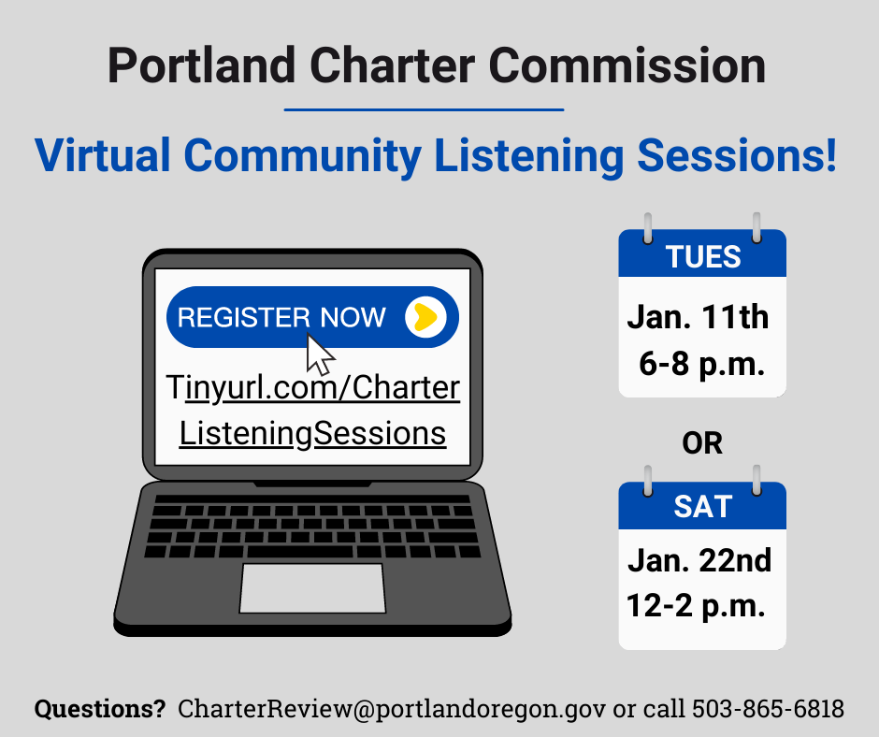

The Portland Charter Commission is inviting you to their virtual Community Listening Sessions! Come learn from Commissioner about the charter review process, the options of reform for our government and elections, and join small breakout rooms to have a community discussion with Commissioners on these options! Community members are invited to attend either of the **Part II**Community Listening Sessions. The sessions will have the same content just offered on different days to accommodate more community member: *Tuesday, January 11th from 6-8pm* **or** *Saturday, January 22nd from 12-2pm*. Learn more about Charter and register here: Tinyurl.com/CharterListeningSessions